**Open Search**

# 

# Introduction

OpenSearch is a scalable, flexible, and extensible open-source software suite for search, analytics, and observability applications licensed under Apache 2.0. Powered by Apache Lucene and driven by the OpenSearch Project community, OpenSearch offers a vendor-agnostic toolset you can use to build secure, high-performance, cost-efficient applications. Use OpenSearch as an end-to-end solution or connect it with your preferred open-source tools or partner projects.

# Project Summary

|  |  |
| --- | --- |
| Website | https://opensearch.org/ |
| Organization/Foundation Name | Amazon Web Services (AWS) |
| License | Apache 2.0. |
| Open/Proprietary | open-source project |
| Source Path(if open source) | https://github.com/opensearch-project |
| Brief Description | OpenSearch is an open-source, community-driven search and analytics suite. It is a fork of the Elasticsearch and Kibana projects, created by Amazon after they decided to no longer support and develop the open-source version of these products, and made them proprietary. |

# Project Details

Anomaly detection - Identify atypical data and receive automatic notifications.

KNN - Find “nearest neighbors” in your vector data.

Performance Analyzer - Monitor and optimize your cluster.

SQL - Use SQL or a piped processing language to query your data

Index State Management - Automate index operations.

ML Commons plugin - Train and execute machine-learning models.

Asynchronous search - Run search requests in the background.

Cross-cluster replication - Replicate your data across multiple OpenSearch clusters.

## 

## Architecture

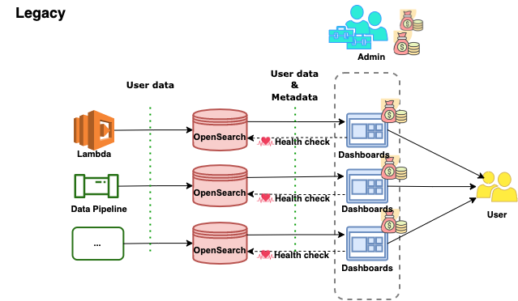

## Current Usage

The OpenSearch project is an open-source, community-driven search and analytics platform that provides advanced search capabilities and analytics features for various types of data. OpenSearch was launched in March 2021 by Amazon Web Services (AWS) as an open-source fork of Elasticsearch and Kibana, two popular search and analytics projects.

Currently, OpenSearch is being used by various organizations and companies for a wide range of applications, including enterprise search, log analytics, security analytics, and business intelligence. Some notable users of OpenSearch include Adobe, Cisco, Cloudflare, and Verizon.

OpenSearch is also being actively developed by a growing community of contributors and is being integrated into various other open-source projects, such as Grafana, Apache Superset, and Open Distro for Elasticsearch. The project has gained significant momentum and is expected to continue to grow and evolve in the coming years.

## Technical Details

OpenSearch is an open-source search and analytics suite that provides advanced search capabilities and is built on top of Elasticsearch, Kibana, and Logstash (also known as the "Elastic Stack"). Here are some technical details about the OpenSearch project:

Architecture: OpenSearch is a distributed search and analytics system. It is built on top of Elasticsearch, which is a distributed search engine, and uses Kibana for data visualization and Logstash for data processing. It has a distributed architecture that can scale horizontally by adding more nodes to the cluster.

API: OpenSearch provides a RESTful API that can be used to interact with the system. The API allows users to perform CRUD (create, read, update, delete) operations on data, as well as perform complex search queries and aggregations.

Plugins: OpenSearch supports plugins that can extend its functionality. There are various plugins available that can add features like security, monitoring, and alerting.

Security: OpenSearch provides security features such as authentication, authorization, and encryption. It allows users to configure access control rules and secure communication channels between nodes in the cluster.

Data Ingestion: OpenSearch provides various ways to ingest data into the system. It supports various data sources such as log files, databases, and messaging systems. It also provides connectors for popular data sources like Kafka, AWS S3, and Azure Event Hub.

Data Visualization: OpenSearch uses Kibana for data visualization. Kibana provides various visualization options such as bar charts, line charts, and heat maps. It also allows users to create custom dashboards and alerts.

Community: OpenSearch is an open-source project with a large and active community. The community provides support, documentation, and plugins to extend the functionality of the system.

### Any other information

OpenSearch is an open-source, community-driven search and analytics suite that is compatible with the Apache 2.0 license. It is based on Elasticsearch, one of the most popular search and analytics engines available today. OpenSearch was developed by AWS, and it is a fork of Elasticsearch and Kibana. The project's mission is to provide an open, reliable, and scalable search and analytics suite that meets the needs of all users.

OpenSearch consists of several components, including the OpenSearch Server, OpenSearch Dashboards, and OpenSearch Alerting. The OpenSearch Server is the search and analytics engine that stores and retrieves data. OpenSearch Dashboards is a visualization tool that enables users to create and share interactive visualizations and reports. OpenSearch Alerting enables users to set up and manage alerts for their search data.

OpenSearch is highly customizable and supports a wide range of use cases, including log analysis, application monitoring, full-text search, and more. It is also highly scalable and can handle large volumes of data, making it an excellent choice for large enterprises and organizations.

In addition, OpenSearch has a vibrant community of developers and users who are actively contributing to the project. The community provides support, documentation, and resources for users who want to learn more about the project or contribute to its development.

### Reference

<https://opensearch.org/>

<https://github.com/opensearch-project/OpenSearch>

<https://en.wikipedia.org/wiki/OpenSearch_(software)>

**-----------------------------End of the template--------------------------------**